**MATH 01 Review Sheet**

1) Compute

a) 

b) 

c) 

d) 

e) 

2) Compute the quotient and remainder

a) 

b) 

c) 

d) 

3) Compute

a) 

b) 

c) 

d) 

e) 

4) Reduce to lowest terms

a) 

b) 

5) Give prime factorization of

1. 105
2. 132
3. 60

6) Change to a mixed number

a) 

b) 

7) Change to an improper fraction

a) 

b) 

8) Compute

a) 

b) 

c) 

d) 

9) Compute

a) 

b) 

c) 

d) 

10) Compute

a) 

b) 

c) 

11) Find the Least Common Multiple and the Greatest Common Factor of

a) 12 and 18

b) 108 and 144

c) 10, 15 and 25

12) Compute

a) 

b) 

c) 

d) 

e) 

13) Compute

a) 

b) 

c) 

d) 

e) 

14) Arrange from smallest to largest

a) 

b) 

c) 

15) Change to a decimal rounded to the nearest tenth

a)  b) 67.86%

16) Change to a reduced fraction

a) 65% b) 0.125

17) Change to a percent rounded to the nearest tenth

a)  b) 2.3575

18) Compute

a) 

b) 

c) 

d) 

e) 80% of 12

19) Compute

a)  b) 

c)  d) 

e)  f) 

g)  h) 

20) Evaluate if 

a) 

b) 

c) 

d) 

21) Solve for x

a) 

b) 

c) 

d) 

22) What is the area of a rectangle of width 6 and length 14?

23) Three out of four students at a certain college are enrolled in Liberal Arts. If the college has 1720 students, how many are enrolled in Liberal Arts?

24) How much would 16 gallons of gas cost at $3.35 a gallon?

25) A student receives grades of 84, 79 and 82 on her first three Chemistry exams. What grade must she get on her next test to raise her average to 85?

26) Find the area and the perimeter:

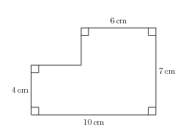

27) Candy bars cost $1.30 each. How much change should you get from $10 bill if you buy 6 bars?

28) How many 40 gallon drums can be filled from a tank containing 650,000 gallons of oil?

29) Jack saves $32 a week to buy a TV set that costs $589. After twelve weeks, how much more money will he need to save for it?

30) A jacket sells for $149. If the price goes up 5%, what will the new price be?

31) A club sells 85 tickets to a dance at $30 each. Their expenses are $794.30. How much profit do they make?

32) Find the area and the perimeter

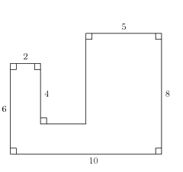

33) If the triangles  and  are similar,  and , compute  and .

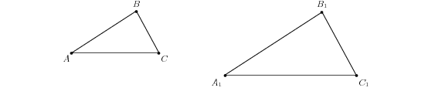

34) a) The lines *AB* and *DE* are parallel. Compute the lengths *CD* and *CE.*

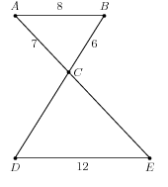

b) The lines *BD* and *CE* are parallel. Compute the length *BC.*

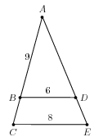

35) 30% of a number is 70. What is the number?

36) If the temperatures on six consecutive days were (in degrees Celsius): , what was the average temperature rounded to the nearest tenth?

37) A store has a 20% off sale. The sale price of a jacket is $72. What is the full price?

38) A store has a 20% off sale. The full price of a jacket is $170. What is the sale price?

39) A cab charges $3.50 for the first  of a mile and $0.25 per  of a mile after that. How much is a 5 mile ride?

40) 10-foot pole casts a 6 ft shadow. How tall is a building casting a 90 ft shadow?

41) For a right triangle with the right angle C (legs a and b, hypotenuse c), compute the missing side.

a) a = 15, c = 17 b) b = 24, c = 25 c) a = 9, b = 12 d) a = 5, b = 2

42) Compute the perimeter and the area of the rectangle with length 12 ft and diagonal 13 ft.

**Answers:**

1. a) 67 b) 2,644 c) 4,200,000 d) 97,344 e) 7.992
2. a) Q=8, R=5 b) Q=11, R=31 c) Q=710, R=51 d) Q=45, R=1
3. a) 81 b) 8 c) 163 d) 15 e) 9
4. a)  b) 
5. a)  b) 

c) 

1. a)  b) 
2. a)  b) 
3. a)  b)  c)  d) 
4. a)  b)  c)  d) 
5. a)  b)  c) 
6. a) LCM = 36, GCF = 6 b) LCM = 432, GCF = 36 c) LCM = 150, GCF = 5
7. a)  b)  c)  d) 14 e) 
8. a) 77.94 b) 1,900 c) 58.08 d) 0.05952 e) 6,400,000
9. a)  b)  c) 
10. a) 0.3 b) 0.7
11. a)  b) 
12. a) 27.3% b) 235.8%
13. a)  b) 8 c) 28 d) e) 9.6
14. a)  b) 7 c)  d)  e) 9 f)  g) 0 h) 
15. a)  b)  c)  d) 
16. a)  b)  c)  d) 
17. 84
18. 1290
19. $53.60
20. 95
21. Area is ,

Perimeter is .

1. $2.20
2. 16,250
3. $205
4. $156.45
5. $1,755.70
6. Area is ,

Perimeter is .

1. , 
2. a) , 

b) 

1. 
2. 
3. $90
4. $136
5. $12.50
6. 150 ft
7. a) b = 8 b) a = 7 c) c = 15 d) 
8. Area is ,

Perimeter is .

(IP,NA , 10/2014)